***===================================================***

***Dt : 7/5/2022***

***Diagram of Product.java***

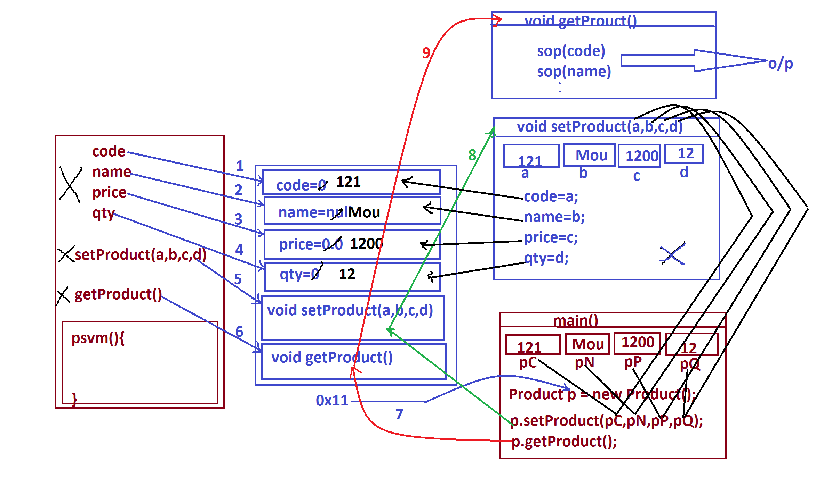

***=====================================================***

***faq:***

***Types of parameters:***

***=>Parameters are categorized into two types:***

***(i)Actual Parameters***

***(ii)Formal Parameters***

***(i)Actual Parameters:***

***=>The parameters which hold original input data and used while***

***method calls are known as Actual Parameters.***

***Ex:***

***pC,pN,pP,pQ***

***(ii)Formal Parameters:***

***=>The parameters which hold intermediate data and used in***

***method signature are known as formal parameters.***

***Ex:***

***a,b,c,d***

***Note:***

***=>Actual parameters and Formal parameters can be declared with***

***same names.***

***============================================================***

***Ex_Program:(Demonstrating return type method)***

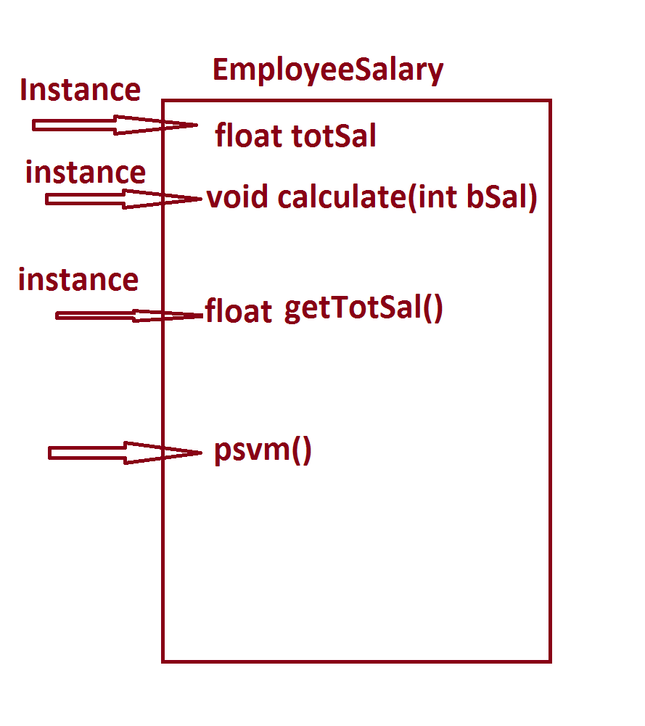

***program : EmployeeSalary.java***

***class EmployeeSalary***

***{***

***float totSal;***

***void calculate(int bSal)***

***{***

***totSal=bSal+(0.93F*bSal)+(0.63F*bSal);***

***}***

***float getTotSal()***

***{***

***return totSal;***

***}***

***public static void main(String[] args)***

***{***

***int bS = 12000;***

***EmployeeSalary es = new EmployeeSalary();***

***es.calculate(bS);***

***float tS = es.getTotSal();***

***System.out.println("TotSal of an Employee="+tS);***

***}***

***}***

***o/p:***

***TotSal of an Employee=30720.0***

***==========================================================***

***Assignment:***

***Layout:***

